CITY ROAD SHARE

INDEX

1. User Module

1.0 OVERVIEW

1.1 Login/Register

1.2 HOME

1.3 SEEKER

1.4 SHARER

1.5 BLOG

1.6 CONTACT

2.Data Base

**CITY ROAD SHARE**

1.0 Overview: City road share is a social networking site through which people can meet up for sharing their ride with in the city. City road share is also known as vehicle-sharing and ride-sharing. The main intention of this site is, if you have a vehicle split costs by offering vehicle pools. If you don't have a vehicle, use this application to find a vehicle pool. Through this a Ride Sharer can share his ride with Ride Seeker and Ride Seeker can share a ride with the Ride Sharer. By sharing a ride we can save gas, money and reduce auto emissions and also meet new friends. City road share’s main motto is to control Pollution, parking, traffic and road maintenance.

### 1.1. Login/Register:

### 1.1.1. Login Page: City Road Share customer’s login page allows personal customers, corporate customers, National Customers to login and access the application. New customers can register in Registration page.

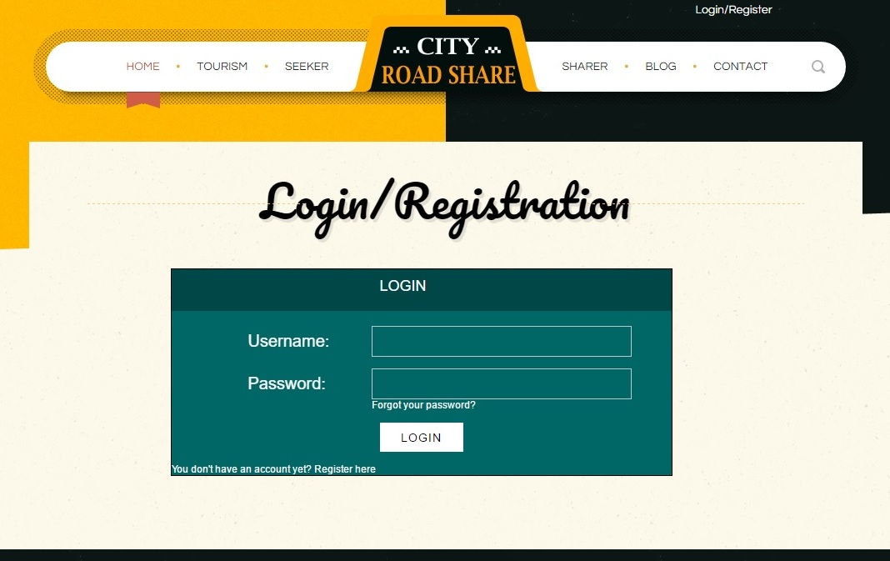

### 1.1.2 Elements of Login Page:

|  |  |  |  |
| --- | --- | --- | --- |
| Element Name | Element Type | User Action | System Response |
| Username | Edit Box | Enter/Edit | System accepts the data. |
| Password | Edit Box | Enter/Edit | System accepts the data. |
| Forgot Your Password | Text | Click | System Redirects to corresponding page. |
| Login | Button | Click | 1. If data is valid: System displays Customer Home Page.  2. If data is invalid: System displays error message |
| Register Here | Text | Click | System Redirects to Registration page. |

### 1.1.3. Forgot Password:

If customer forgets the registered password then he asks to enter the registered Email, an OTP is sent to email which we need to enter. If OTP matches it allows customer to create new password.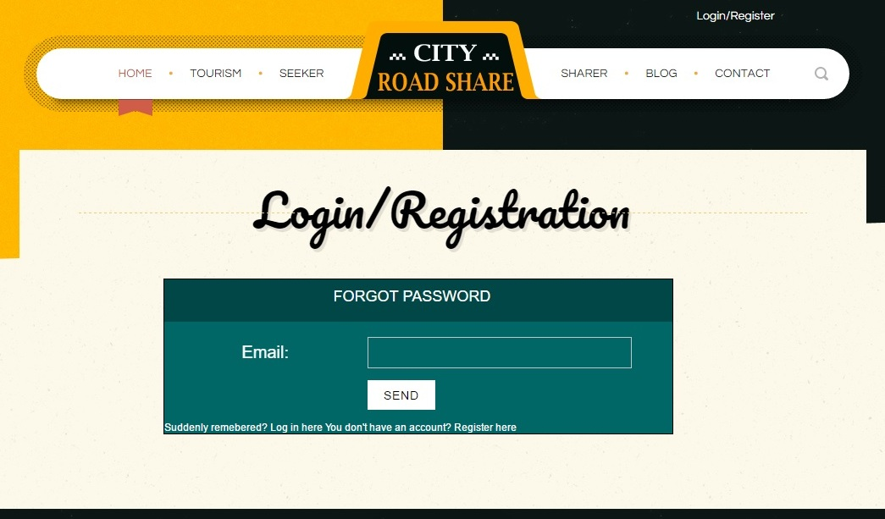

### 1.1.4 Elements of Reset Password Page:

|  |  |  |  |
| --- | --- | --- | --- |
| Element Name | Element Type | User Action | System Response |
| Email | Edit Box | Enter/ Edit | System accepts the data. |
| Send | Button | Clicks | 1. If valid Email then OTP should be sent to Email.  2. If not valid display text “Enter valid Email”. |
| Login Here | Link | Clicks | System Redirects to Login page. |
| Register Here | Link | Clicks | System Redirects to Registration page. |

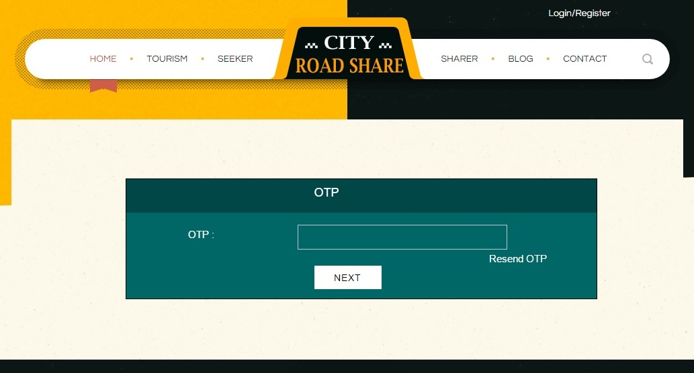

### 1.1.5 Elements of Reset Password Page:

|  |  |  |  |
| --- | --- | --- | --- |
| Element Name | Element Type | User Action | System Response |
| OTP | Edit Box | Enter/ Edit | System accepts the data. |
| Resend OTP | Button | Clicks | System should send OTP to Email. |
| Next | Link | Clicks | 1. If valid OTP, system should redirects to password reset page.  2. If not valid display text “Enter valid OTP”. |

### newpwd

### 1.1.6 Elements of Reset Password Page:

|  |  |  |  |
| --- | --- | --- | --- |
| Element Name | Element Type | User Action | System Response |
| Email Id | Edit Box | Enter/ Edit | System accepts the data. |
| New Password | Edit Box | Enter/ Edit | System accepts the data. |
| Confirm New Password | Edit Box | Enter/ Edit | 1. If New Password doesn’t match then “Password doesn’t match”.  2. If not valid display text “Enter valid Email”. |
| Next | Button | Clicks | System Redirects to corresponding page. |

### 1.1.7 Registration Page:

New customers who willing to share a ride or seek a ride will register here by entering valid details, if details are correct system creates a new user.

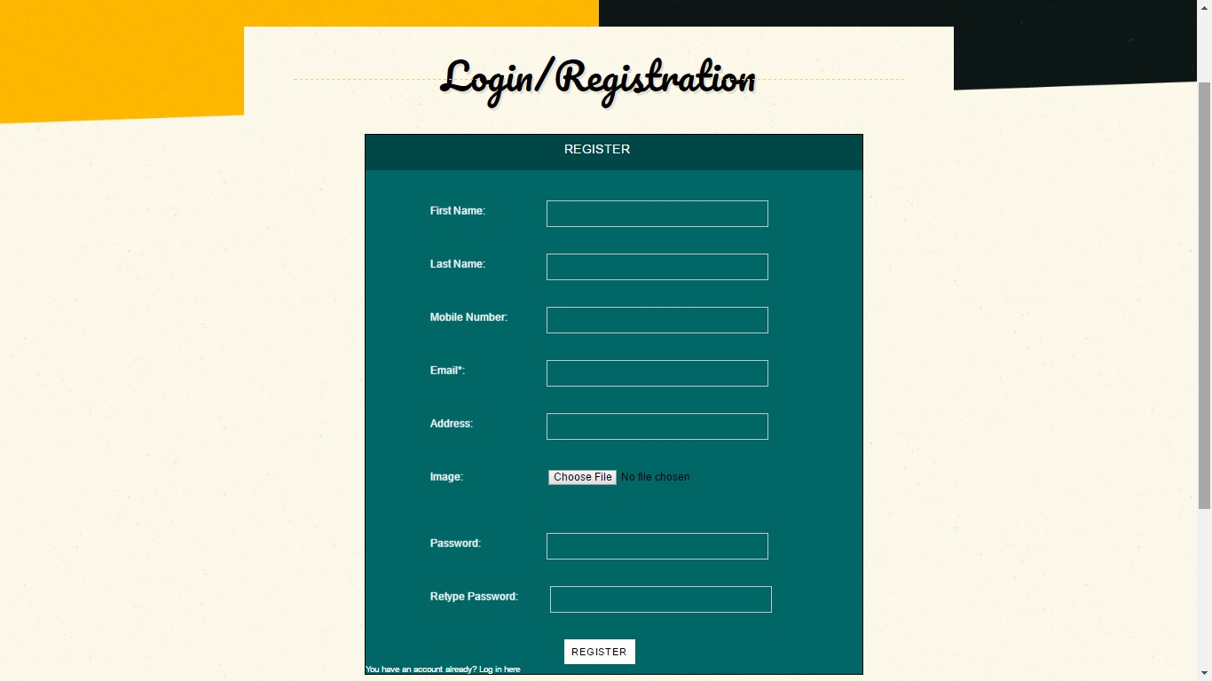

### 1.1.7 Elements of Sharer Page:

|  |  |  |  |
| --- | --- | --- | --- |
| Element Name | Element Type | User Action | System Response |
| First Name | Edit Box | Enter/Edit | 1. If Blank – “Please fill in the following fields – First Name”.  2. If Invalid Chars- “This field should contain only alphabets”. |
| Last Name | Edit Box | Enter/Edit | 1. If Blank – “Please fill in the following fields – Last Name”.  2. If Invalid Chars- “This field should contain only alphabets”. |
| Mobile Number | Edit Box | Enter/Edit | 1. If Blank – “Please fill in the following fields – Mobile”.  2. If Invalid Chars- “This field should contain only 10 numeric values”.  3. If Invalid Range- “the number should start with7/8/9”. |
| Email | Edit Box | Enter/Edit | 1. If Blank – “Please fill in the following fields – Email”. |
| Address | Edit Box | Enter/Edit | 1. If Blank – “Please fill in the following fields – address”. |
| Image | Button | Click | System should accept and corresponding should display in Image Preview. |
| Password | Edit Box | Enter/Edit | 1.If Blank – “Please fill in the following fields – Password”  2. If Invalid Range- “This field should be with minimum of 8 chars range. |
| Retype Password | Edit Box | Enter/Edit | If not matching with Password- System should display text Password not matching |
| Element Name | Element Type | User Action | System Response |
| Register | Button | Click | If user enters valid data System should create a new customer successfully. And redirect to the Home Page. |
| Login here | Link | Click | System redirect to the Login Page. |

### 1.1.8 Login Task Flow Diagram:

Home Page

Login

Register

Enter valid URL

Enter Username & password

New customer

Customer Home Page

Valid Email and

Password

Valid Registration details

Creating New Password

Forgot password &

Enter Valid OTP

1.2 City Road Share Homepage:

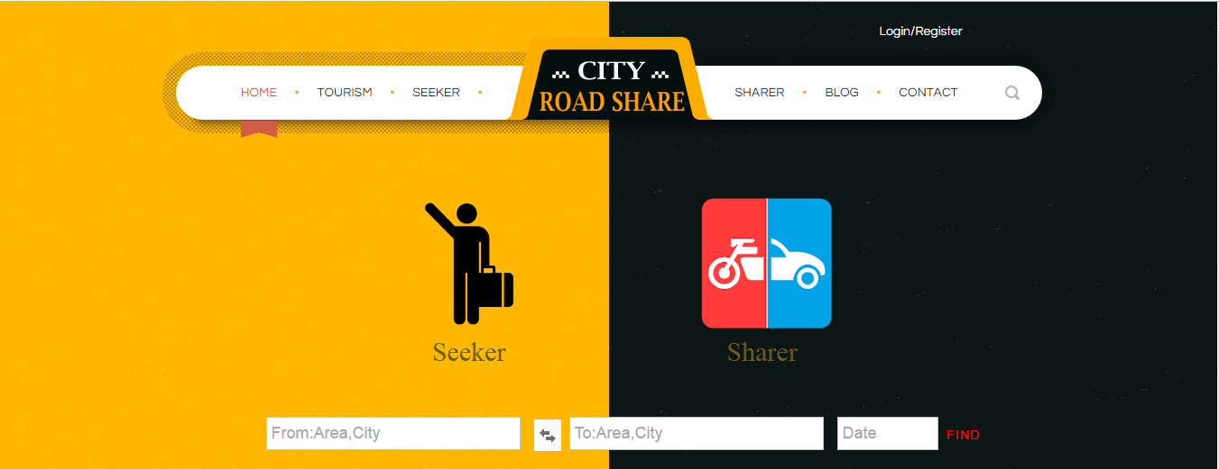

1.2.1 Elements of City Road Share:

|  |  |  |  |
| --- | --- | --- | --- |
| Element Name | Element Type | User Action | System Response |
| Home | Tab | Click | System displays the City Road Share Homepage |
| Tourism | Tab | Click | System displays the tourism page |
| Element Name | Element Type | User Action | System Response |
| City Road Share | Tab/Image | Click | System displays the Home Page |
| Sharer | Tab | Click | System displays the Sharer Login/Registration |
| Blog | Tab | Click | System displays the Blog page |
| Contact | Tab | Click | System displays the contact details of Crs. |
| Search | Tab/Image | Click | System will redirect to the particular item you are entered |
| Seeker | Tab/Image | Click | System will displays the Seeker page |
| Sharer | Tab/Image | Click | System will displays the sharer page |

1.2.2 User Credentials

|  |  |  |  |
| --- | --- | --- | --- |
| Element name | Element type | User Action | System Response |
| Login | Tab | Click | System will redirects to the login page |
| Register | Tab | Click | System will redirects to the registration page |
| From | Textbox | Enter Text | System will take the area and city form the user and it will checks from the database. |
| To | Textbox | Enter Text | System will take the area and city form the user and it will checks from the database. |
| Date | Textbox/Date picker | Select date from calendar. | System will displays the calendar and it will select the date from that calendar. |
| Find | Tab | Click | System will take the data from user and check the data from the database. |

1.2.3 Steps for City Road Share:

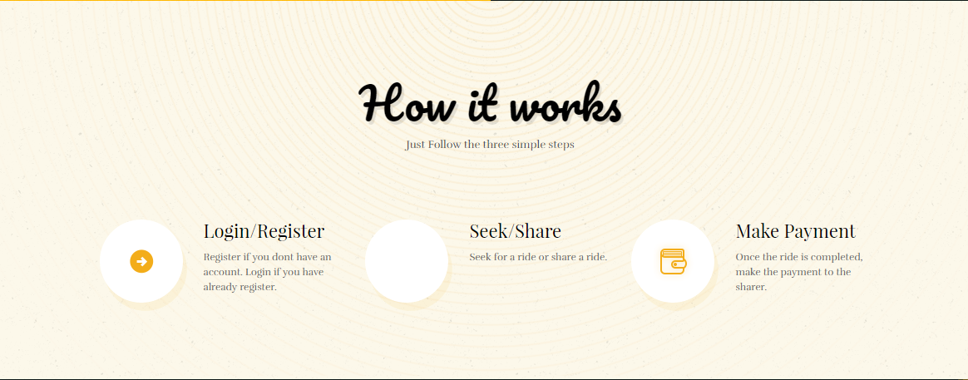

In these it will tell the steps how the CRS will work. Basically it is working on Three Simple Steps.

**1. Login/Register:** User has to register if User don’t have an account and login if user is already register.

**2. Seek/Share:** In these seeker and sharer are main modules from user side. Sharer will share their ride and seeker will search for a ride if seeker ride is suitable for the sharer ride then seeker will select the ride and these sharer details will be displayed to the seeker and seeker details will also displayed to the sharer and sharer is able to accepts or rejects the seeker.

**3. Make Payment:** In the payment the seeker will pay the money to the sharer before or after the completion of their drive by the sharer.

1.2.4 City Road Share Services:

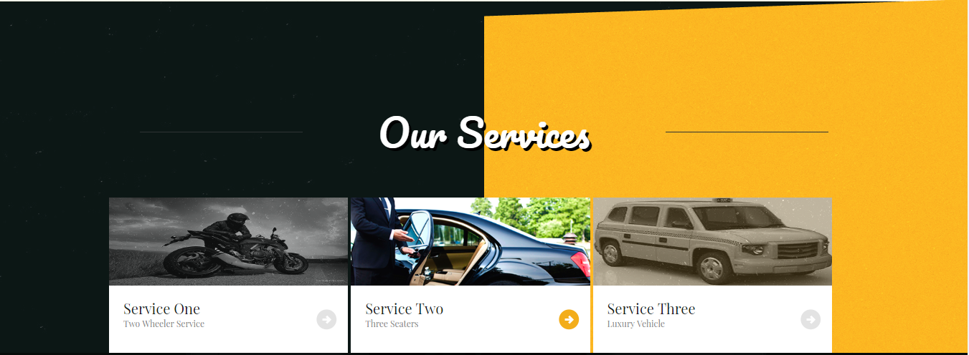

Mainly CRS is providing three services and it depends on number of seekers.

**Service One – Two Wheeler Service:** Sharer will share the ride on two wheeler and seeker will book a ride on two wheeler.

**Service Two – Three Seaters:** Sharer will share the ride on car and seeker will book the car for Travelling.

**Service Three – Luxury Vehicle:** Sharer will share the ride on luxury vehicle and seeker will book the luxury car for Travelling.

1.2.5 User Suggestions:

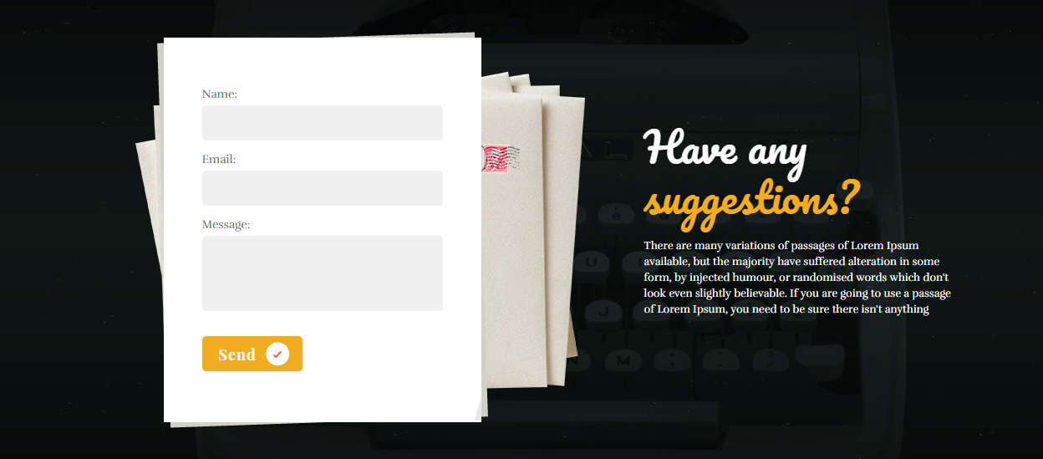

In Home page user is able to give any suggestions regarding City Road Share. These suggestions will store into the Database.

|  |  |  |  |
| --- | --- | --- | --- |
| Element Name | Element Type | User Action | System Response |
| Name | Textbox | Enter Text | System will take the name that you are entering |
| Email | Textbox | Enter Text | **If Valid:** System will take the email that user is entering  **If Invalid:** Please enter the valid email |
| Element Name | Element Type | User Action | System Response |
| Message | Textbox | Enter Text | System will take the message that user is entering |
| Send | Button | Click | **If Valid:** System will take the values from the user and stored in the database  **If Invalid**: Fill The Required field |

1.2.6 News & Special offers Regarding City Road Share:

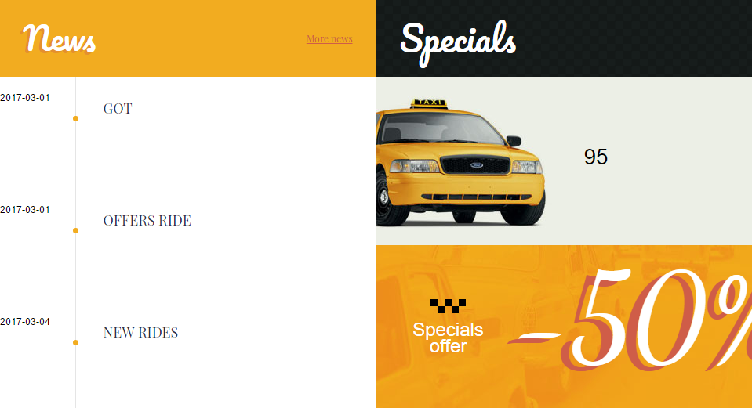

In news & offers Window .they will update the news & offers regarding City Road Share and by monthly wise it is showing the news & offers. If you click more news present on the top of the news window it will redirect to the Blog and in the Blog all the news are available regarding the City Road Share.

1.2.7 Hyperlinks Available on footer:

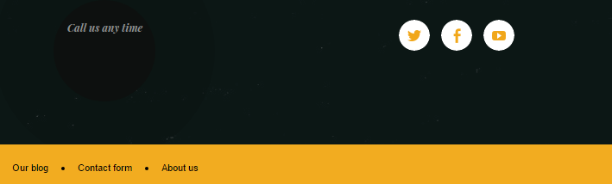

|  |  |  |  |
| --- | --- | --- | --- |
| Element Name | Element Type | User Action | System Response |
| Our blog | hyperlink | Click | System will redirect to the blog page of the CRS. |
| Contact form | hyperlink | Click | System will redirect to the Contact page of the CRS. |
| About us | hyperlink | Click | System will redirect to the about us page of the CRS. |
| Twitter-Icon | Icon/hyperlink | Click | System will redirect to the Twitter CRS page |
| Facebook-Icon | Icon/hyperlink | Click | System will redirect to the Facebook CRS page. |
| You tube-Icon | Icon/hyperlink | Click | System will redirect to the You tube CRS page. |

1.3 Seeker:

The user has to login. Once the seeker logs in, the seeker will be able to view his/her previous ride details. If the seeker want to find a new ride, then he/she must click on the “Find a Ride” button.

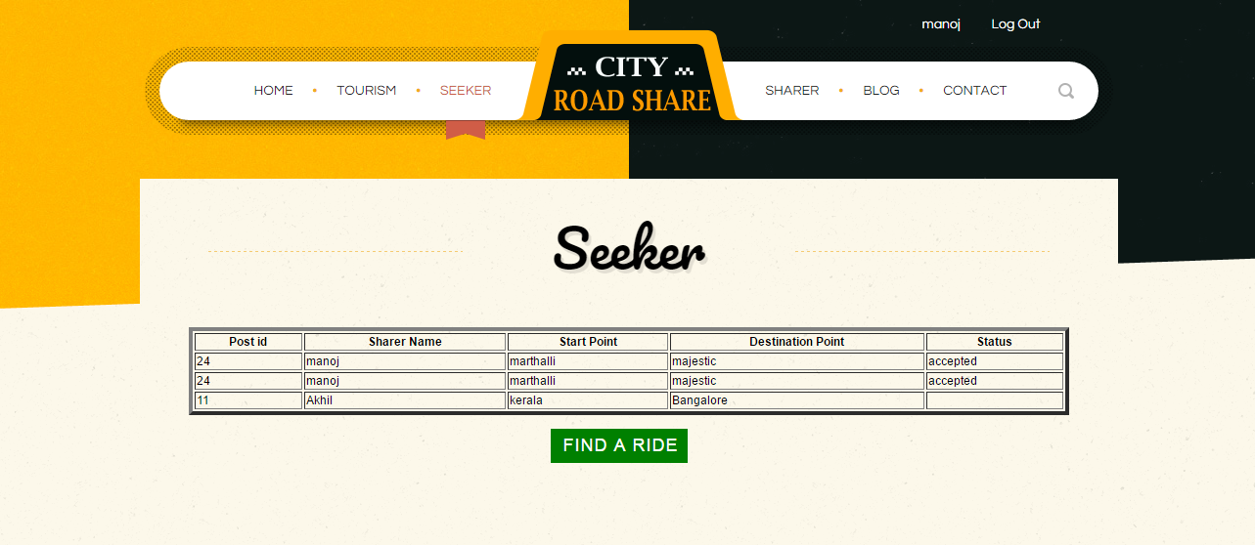

|  |  |  |  |
| --- | --- | --- | --- |
| Element Name | Element Type | User Action | System Response |
| FIND A RIDE | Button | Click | System will redirect to find a ride page. |

Here seeker will see the details of the previous ride with the sharer along with Post id, Sharer Name, Start point, Destination point and Status.

If seeker wants to find a ride then seeker has to click the find a ride button present on the seeker page then it will redirect to the Find a ride page as shown below.

1.3.1 Seeker-Find a Ride:

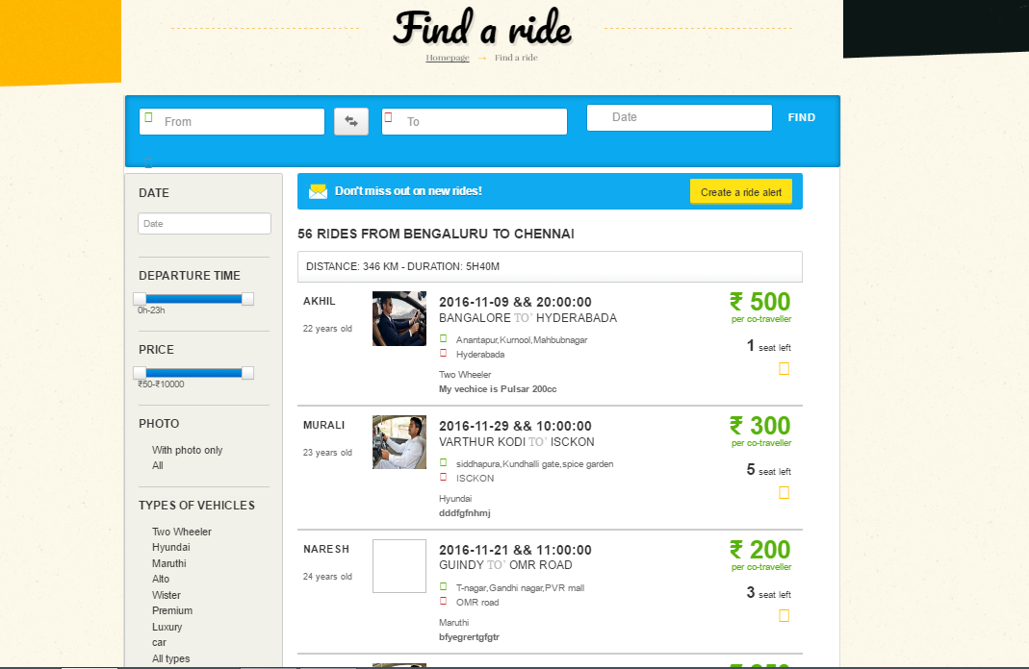

In Find a Ride page seeker has to enter “From-To” and Select the date and click the find button then it will display the list of seekers along with their details. If seeker wants to see the sharer details sort by date, Sort by departure time, Sort by Price, Sort by Photo, Sort by Types of vehicles by using the tab present on the right side of the page.

If seeker wants to create alerts for rides by sharer then seeker will click the Create a ride alert button present in the top and seeker has to enter the email in the textbox then seeker will get the alerts regarding the rides of City Road Share.

|  |  |  |  |
| --- | --- | --- | --- |
| Element Name | Element Type | User Action | System Response |
| From | Textbox | Enter Text | System will take the text |
| To | Textbox | Enter Text | System will take the text |
| Date | Date picker | Select the date | System will take the date |
| Find | Button | Click | System will take from, to, date then it will checks the database and display the sharer details. |

|  |  |  |  |
| --- | --- | --- | --- |
| Element Name | Element Type | User Action | System Response |
| Create a ride alert | Button | Click and enter the text | System will take that text and stored in the database |
| Departure Time | Slider | Move the slider | System will take the seeker response and it will give the details of the sharer. |
| Price | Slider | Move the Slider | System will take the seeker response and it will give the details of the sharer. |
| Photo-With photos only | Tab | Click | System will take the seeker response and it will give the details of the sharers sort by Photos |
| Photo-All | Tab | Click | System will take the seeker response and it will give the details of all sharers. |

|  |  |  |  |
| --- | --- | --- | --- |
| Element Name | Element Type | User Action | System Response |
| **Types of vehicles** -Two wheeler | Tab | Click | System will take the seeker response and it will display all the sharers which are using two wheelers. |
| **Types of vehicles** -  Hyundai | Tab | Click | System will take the seeker response and it will display all the sharers which are using Hyundai. |
| **Types of vehicles** -Maruthi | Tab | Click | System will take the seeker response and it will display all the sharers which are using Maruthi. |
| **Types of vehicles** -  Alto | Tab | Click | System will take the seeker response and it will display all the sharers which are using Alto. |
| **Types of vehicles** -  Wister | Tab | Click | System will take the seeker response and it will display all the sharers which are using Wister. |

|  |  |  |  |
| --- | --- | --- | --- |
| Element Name | Element Type | User Action | System Response |
| **Types of vehicles** -Premium | Tab | Click | System will take the seeker response and it will display all the sharers which are using Premium. |
| **Types of vehicles -**luxury | Tab | Click | System will take the seeker response and it will display all the sharers which are using luxury. |
| **Types of vehicles** -  car | Tab | Click | System will take the seeker response and it will display all the sharers which are using car. |
| **Types of vehicles** -  Audi | Tab | Click | System will take the seeker response and it will display all the sharers which are using Audi. |
| **Types of vehicles**-  All Types | Tab | Click | System will take the seeker response and it will display all the sharers details. |

1.3.2 Sharer Details (Driver details):

Sharer Details are available on Driver details page. If seeker wants to see the ride details then seeker will click that sharer it will redirect to the Driver details.

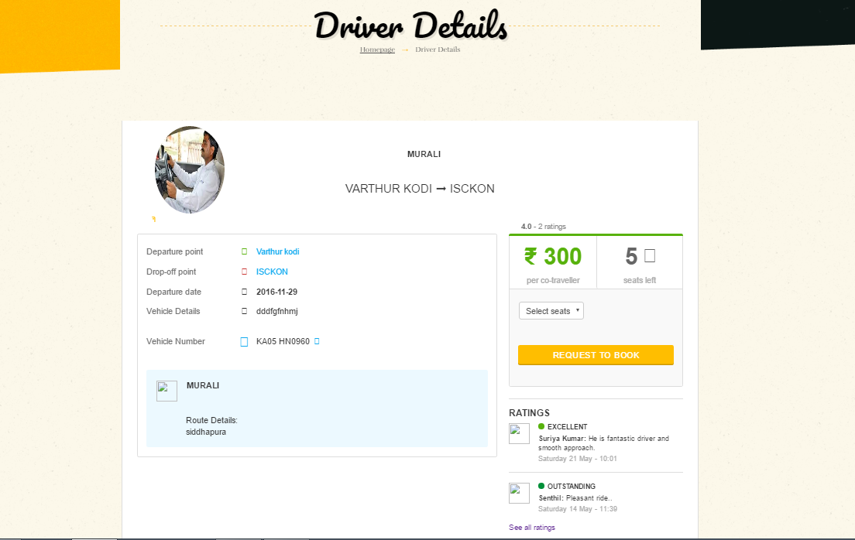

The sharer details is displayed in driver details page. Here vehicle number, departure date, time all the details related to the sharer is displayed on left side of the page.

The ratings of the driver, amount per co-traveler, Number of seats available is displayed on left side of the page. On right side of the page seeker will select the number of seats and seeker will book the vehicle. If seeker wants to see the all reviews of particular sharer then SEE ALL RATINGS hyperlink is available if user clicks that link then it will show all the ratings of the sharer.

|  |  |  |  |
| --- | --- | --- | --- |
| Element name | Element Type | User Response | System Response |
| Select Seats | Dropdown | Select | System will take the response from the sharer. |
| Request to book | Button | Click | System will take the response and it will stores in the database |
| See All Ratings | Hyper link | Click | System will display the all the ratings of a sharer |
| Find a ride | Button | Click | System will redirect to the Find a ride page and display the details of the sharer. |

1.3.3 Seeker Confirmation Details:

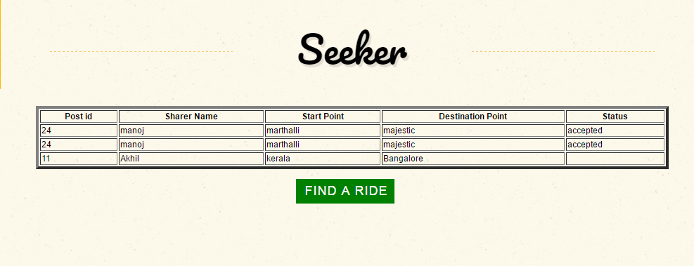

If seeker book a ride then sharer has to accept or reject that ride if sharer accepts that ride then in seeker page status is changed to accepted if sharer rejects then in seeker page status is changed to rejected.

## 1.4 Sharer:

### 1.4.1 Overview:

Sharer feature allows posting a ride or modifying the status of booking details and can accepting or rejecting the seeker’s ride.

### 1.4.2 Sharer Page Details:

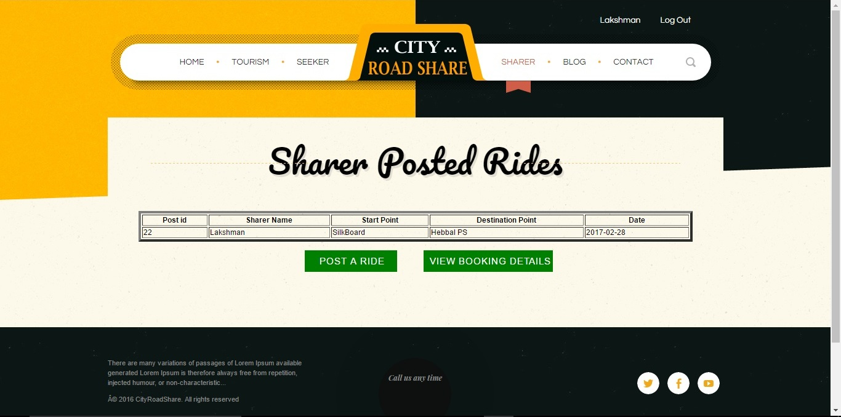

## 1.4.3 Elements of Sharer Page:

|  |  |  |  |
| --- | --- | --- | --- |
| **Element Name** | **Element Type** | **User Action** | **System Response** |
| Post Id | Table Element | Auto Display, Read Only | Sharer Ids should display |
| Sharer Name | Table Element | Read Only | Sharer Names should display |
| Start Point | Table Element | Read Only | Sharer starting point should display |
| Destination Point | Table Element | Read Only | Sharer destination should display |
| Date | Table Element | Read Only | Sharing ride dates should display |
| Post A Ride | Button | Click | System displays the respective page with Ride details |
| View Booking Details | Button | Click | System displays the respective page with Ride Booking details |

### 1.4.6 Sharer Post A Ride Details:

If a sharer want to post a ride then he need to fill all the corresponding details and click the post button which includes name, starting point, destination, date of journey, mobile number, vehicle type, vehicle details, number of sharing seats, price per each seat, driving license and one image.

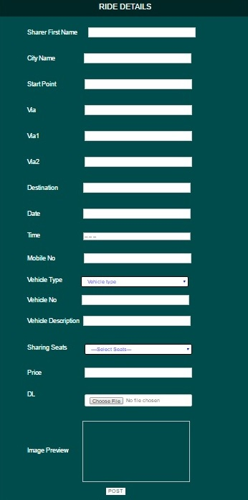

### 1.4.7 Sharer Post A Ride Elements:

|  |  |  |  |
| --- | --- | --- | --- |
| **Element Name** | **Element Type** | **User Action** | **System Response** |
| Sharer First Name | Edit Box | Enter/Edit | 1.If Blank – “Please fill in the following fields – Sharer First Name”  2.If Invalid Chars- “This field should be with an alphabet”  3. If Invalid Range- “This field should be within 4 - 10 chars range. |
| City Name | Edit Box | Enter/Edit | 1.If Blank – “Please fill in the following fields – City Name”  2.If Invalid Chars- “This field should be with an alphabet”  3. If Invalid Range- “This field should be within 4 - 10 chars range. |
| Start Point | Edit Box | Enter/Edit | 1. If Blank – “Please fill in the following fields – Start Point”.  2.If Invalid Chars- “This field should be with an alphabet”  3. If Invalid Range- “This field should be with minimum of 4 chars range. |
| Via | Edit Box | Enter/Edit | 1. If Blank – “Please fill in the following fields – Via”.  2. If Invalid Range- “This field should be with minimum of 4 chars range. |
| Via1 | Edit Box | Enter/Edit | 1. If Blank – “Please fill in the following fields – Via1”.  2. If Invalid Range- “This field should be with minimum of 4 chars range. |
| Via2 | Edit Box | Enter/Edit | 1. If Blank – “Please fill in the following fields – Via2”.  2. If Invalid Range- “This field should be with minimum of 4 chars range. |
| Destination | Edit Box | Enter/Edit | 1. If Blank – “Please fill in the following fields – Destination”.  2. 2.If Invalid Chars- “This field should be with an alphabet”  3. If Invalid Range- “This field should be with minimum of 4 chars range. |
| Date | Combo Box & Edit Box | Select and Enter. | System should accept and page should get refresh, corresponding Date should display in Journey Date. |
| Time | Combo Box & Edit Box | Select and Enter. | System should accept and page should get refresh, corresponding Date should display in Journey Date. |
| Mobile No | Edit Box | Enter/Edit | 1. If Blank – “Please fill in the following fields – Mobile No”.  2. If Invalid Chars- “This field should be with an numeric”.  3. If Invalid Range- “This field should be 10 chars range. |
| Vehicle Type | List Box | Select an in-built state | System should accept and page should get refresh, corresponding vehicle type should display in Vehicle Type List box. |
| Vehicle Number | Edit Box | Enter/Edit | 1. If Blank – “Please fill in the following fields – Vehicle Number”.  2. If Invalid Chars- “This field should be with an 2 alphabet 2 number followed by one or two letter followed by 4 number”.  3. If Invalid Range- “This field should be within 7 - 10 chars range. |
| Vehicle Description | Edit Box | Enter/Edit | 1. If Blank – “Please fill in the following fields – Vehicle Description”. |
| Sharing Seats | List Box | Select an in-built state | System should accept and corresponding sharing seat number should display in Sharing Seats. |
| Price | Edit Box | Enter/Edit | 1. If Blank – “Please fill in the following fields – Price”.  2. If Invalid Chars- “This field should be with a number”. |
| Driving License | Button | Click & Select corresponding Driving License Image | System should accept and corresponding should display in Image Preview. |
| Image Preview | Image | Enter/Edit | System should display Driving License file in Image Preview. |
| Post | Button | Click | If user enters valid data System should create a new ride successfully. And redirect to the Sharer Page. |

### 1.4.8. Sharer accepts or rejects Seeker:

A sharer after posting a ride he can get the current status of the ride. If any customer is seeking a ride then firstly seeker requests for seats and if sharer wants he can accept or reject his request.

### 1.4.8.1 Elements of Reset Password Page:

|  |  |  |  |
| --- | --- | --- | --- |
| **Element Name** | **Element Type** | **User Action** | **System Response** |
| Post Id | Table Element | Auto Display | Sharer Ids should display |
| Sharer Name | Table Element | Read Only | Sharer Names should display |
| Start Point | Table Element | Read Only | Sharer starting point should display |
| Destination Point | Table Element | Read Only | Sharer destination should display |
| Date | Table Element | Read Only | Sharing ride dates should display |
| Rejected button | Button/Icon | Click | Sharer rejects seekers request and system should display “Rejected” message to seeker & sharer also. |
| Accepted button | Button/Icon | Click | Sharer accepts seekers request and system should display “Accepted” message to seeker & sharer also. |
| Post A Ride | Button | Click | System displays the respective page with Ride details |
| View Booking Details | Button | Click | System displays the respective page with Ride Booking details |

### 1.4.9 Sharer Task Flow Diagram:

CRS Home Page

Sharer Page

Posting Ride

Booking Details

Accepts/Rejects seekers ride

Sharer Booking Details Page

Login with valid

Username & Password

Sharer Blog

If Sharer wants to  
Post a ride

Checking Status

Booking Status

Booking Status

Registering Ride

1.5 Blog:

In City Road Share If user clicks the Blog tab than it will redirect into our Blog page in that all the news related to the City Road Share as shown below.

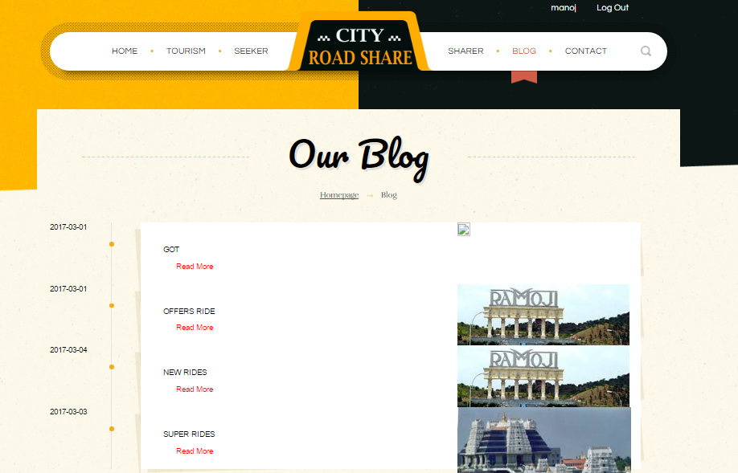

Here if the user want to see the blog details then user will click Read More then it will redirect to the blog page. In the blog page they will display the details regarding the particular blog that user is selecting.

1.5.1 Comments on Blog Page:

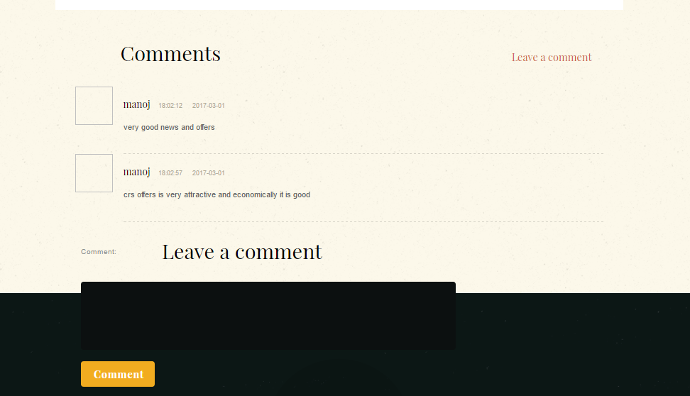

If user want to comment about the blog then user is able to write the comment in the textbox present in the bottom of the blog page and after completion user have to click the comment button to post that comment.

|  |  |  |  |
| --- | --- | --- | --- |
| Element Name | Element Type | User Action | System Response |
| Read more | hyperlink | Click | System will redirect to blog page. |
| Leave a comment | Multiline textbox | Enter Text | System will take the text that user is entering |
| Comment | Button | Click | System will take the comment and stored in the database. |

## 1.6 Contact:

If any user/ customer feel inconvenience or if he feels to change something with the services he could leave a message to admin. We have map to know the navigation also.

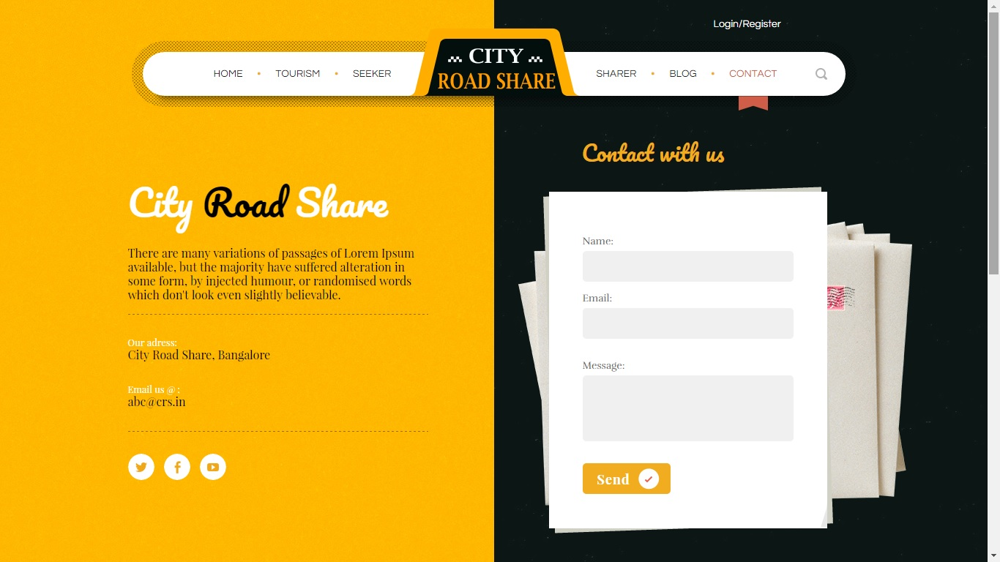

### 1.6.1 Elements of Reset Password Page:

|  |  |  |  |
| --- | --- | --- | --- |
| **Element Name** | **Element Type** | **User Action** | **System Response** |
| Name | Edit Box | Enter/Edit | Accept the data. |
| Email | Edit Box | Enter/Edit | Accept the data. |
| Message | Edit Box | Enter/Edit | Accept the data. |
| Send | Button | Click | System stores feedback and redirects to home page. |

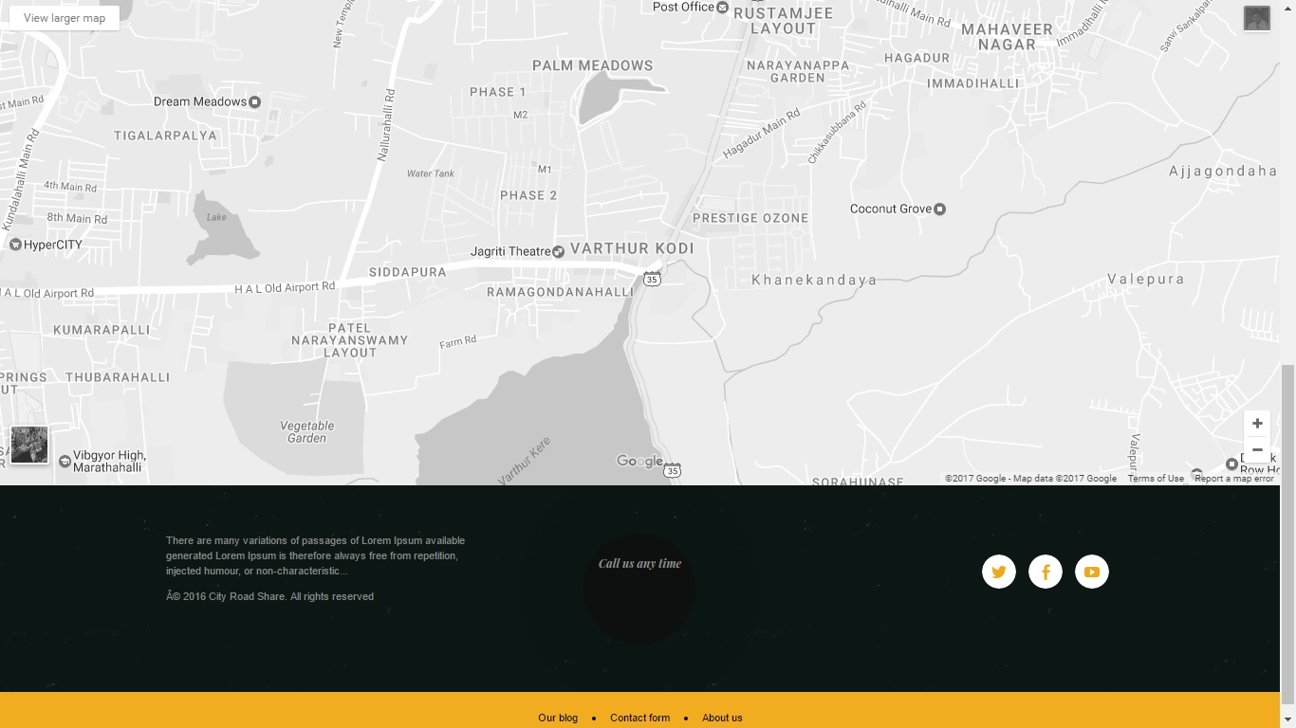

### 1.6.2 Elements of Map:

|  |  |  |  |
| --- | --- | --- | --- |
| **Element Name** | **Element Type** | **User Action** | **System Response** |
|  | Button | Click | System zoom-in the map. |
|  | Button | Click | System zoom-out the map. |
| View Larger Map | Button | Click | System redirects to Google maps |
| Satellite Imagery | Frame | Click | System stores feedback and redirects to CRS home page. |

2.0 DATABASE

|  |  |  |
| --- | --- | --- |
| Table name | Column names | Foreign key Table name |
| boardingpoints | Id(int)-PK,Start_point(varchar),via(varachar),destination(varchar) |  |
| Category | Category_id(int)-PK,  Category_name(varchar) | , |
| Comments | Comment_id(int)-PK,news_id(int)-FK,user_id(int)-FK,date(date),time(time),comment(varchar) | News_id(int)-news_offers,  Users_id(int)-users |
| Customer | Post_id(int),vehicle_type(varchar),vehicle_number(varchar),destination(varchar),using_mobile(int),start_point(varchar) |  |
| Driverinfo | Driver_id(int)-PK,first_name(varchar),last_name(varchar),DOB(varchar),gender(varchar),email_id(varchar),mobile_number(bigint),address(varchar),age(int),dl(longblob),place_id(int)-FK,car_type(varchar),seats(int),price(float),car_image(longblob),package_id(int)-FK | Package_id(int)-package,place_id(int)-tourisms |
| Feedback | Feedback_id(int)-PK,post_id(int),user_id(int)-FK,feedback(varchar)rating(int) | User_id(int)-users |
| News-offers | News_id(int)-PK,date(date),heading(varchar),description1(varchar),description2(varchar),quote(varchar),image(longblob),video(varchar),discount(varchar),percentage(int) |  |
| Otp | Id(int),emailed(varchar),otp(varchar) |  |
| Package | Package_id(int)-PK,city_name(varchar),place_name1(varchar), place_name2(varchar), place_name3(varchar),image1(longblob), image2(longblob), image3(longblob),price(double),description(varchar) |  |
| Privatedriverdetails | Id(int)-PK, driver_id(int)-FK, package_id(int)-FK, user_id(int)-FK | User_id(int)-users, package_id(int)-packages, driver_id(int)-privatedriverinfo |
| Privatedriverinfo | driver_id(int)-PK, first_name(varchar), last_name(varchar), dob(varchar), email(varchar), gender(varchar), mobile_number(int), dl(longblob), address(varchar) ,age(int) |  |
| Privatedriverpackagedetails | Id(int)-PK, driver_id(int)-FK, package_id(int)-FK, user_id(int)-FK | User_id(int)-users, package_id(int)-packages, driver_id(int)-driverinfo |
| Privatedrivervisitdetails | Vd_id(int)-PK, driver_id(int)-FK, place_id(int)-FK, user_id(int)-FK | User_id(int)-users, place_id(int)-tourisms, driver_id(int)-driverinfo |
| Riderating | Rating_id(int)-PK,post_id(int)-FK,user_id(int)-FK,rating(int),review(longtext) | User_id(int)-users,post_id(int)-sharerpost |
| Seekerbookings | Booking_id(int)-PK, user_id(int)-FK,Post_id(int)-FK,status(varchar) | User_id(int)-users,post_id(int)-sharerpost |
| Sharerpost | Post_id(int)-PK, user_id(int)-FK, city_name(varchar), start_point(varchar), via(varchar), via1(varchar), via2(varchar), destination(varchar), date(varchar), time(varchar), using_mobile(bigint), vehicle_type(varchar),vehicle_number(varchar), vehicle_description(varchar), sharing_seats(int), price(double), dl_image(longblob) | User_id(int)-users |
| Suggestions | Suggestion_id(int),name(varchar),email(varchar),message(longtext) |  |
| Tourism | Place_id(int)-PK,place_name(varchar),place_description(varchar),city_name(varchar),image1(longblob), image2(longblob), image3(longblob), image4(longblob) |  |
| Users | User_id(int)-PK,first_name(varchar),last_name(varchar),email(varchar),gender(varchar),mobile(bigint),photo(longblob),address(varchar),password(varchar),age(int) |  |